Faculty of Computing

SE-314: Software Construction
Class: BESE 15AB

Lab 05: tesT first programming - i

CLO-03: Design and develop solutions based on Software Construction principles.
CLO-04: Use modern tools such as Eclipse, NetBeans etc. for software construction.

Date: 09th Oct 2026
Time: 09:00 AM - 11:50 AM
02:00 PM – 04:50 PM

Instructor: Dr. Sidra Sultana
Lab Engineer: Mr. Aftab Farooq

Lab 05: Test- First Programming: Tweet Tweet

Introduction:

Students will have hands-on experience of test-first programming. Given a set of specifications, you will write unit tests that check for compliance with the specifications, and then implement code that meets the specifications.
Material: https://ocw.mit.edu/ans7870/6/6.005/s16/psets/ps1/
Lectures on LMS regarding designing Specifications and Testing

Lab Tasks:
Solve problem 1 and 2 of problem set 1 listed on the link. The goal of the problem set is to build a toolbox of methods that can extract information from a set of tweets downloaded from Twitter.

Test-First Programming:

- Study the specification of the method carefully.
- Write JUnit tests for the method according to the spec.
- Implement the method according to the spec.
- Revise your implementation and improve your test cases until your implementation passes all your tests.

Task1: Extracting data from Tweets
In this problem, you will test and implement the methods in Extract.java. You’ll find Extract.java in the src folder, and a JUnit test class ExtractTest.java in the test folder. Separating implementation code from test code is a common practice in development projects. It makes the implementation code easier to understand, uncluttered by tests, and easier to package up for release

  - Devise, document, and implement test cases for getTimespan() and getMentionedUsers() , and put them in ExtractTest.java .
  - Implement getTimespan() and getMentionedUsers() , and make sure your tests pass.

If you want to see your code work on a live sample of tweets, you can run Main.java . ( Main.java will not be used in grading, and you are free to edit it as you wish.)

Hints:
- Note that we use the class Instant to represent the date and time of tweets. You can check this article on Java 8 dates and times to learn how to use Instant .
- You may wonder what to do about lowercase and uppercase in the return value of getMentionedUsers() . This spec has an underdetermined postcondition, so read the spec carefully and think about what that means for your implementation and your test cases.
- getTimespan() also has an underdetermined postcondition in some circumstances, which gives the implementor (you) more freedom and the client (also you, when you’re writing tests) less certainty about what it will return.
- Read the spec for the Timespan class carefully, because it may answer many of the questions you have about getTimespan() .

Task2: Filtering lists of Tweets
In this problem, you will test and implement the methods in Filter.java .
- Devise, document, and implement test cases for writtenBy() , inTimespan() , and containing() , and put them in FilterTest.java .
- Implement writtenBy() , inTimespan() , and containing() , and make sure your tests pass.
Hints:
- For questions about lowercase/uppercase and how to interpret timespans, reread the hints in the previous question.
- For all problems on this problem set, you are free to rewrite or replace the provided example tests and their assertions.

Source Code: Zip your source code and upload one file per group on LMS as well.
Solution

Deliverables:
Compile a single word document by filling in the solution part and submit this Word file on LMS. In case of any problems with submissions on LMS, submit your Lab assignments by emailing it to aftab.farooq@seecs.edu.pk.
Lab Rubrics
 | Lab 05 Test First Programming
Sr. No. | Assessment | Unacceptable | Does Not Meet Expectations | Meets Expectations | Exceeds Expectations
 |  | (0 Marks) | (1-2 Marks) | (3-4 Marks) | (5 Marks)
1 | CLO-03:  Design and Develop the Solution | The student did not submit any work.  OR  The student plagiarized the solution and/or used unfair means. | Implementation of Extract and Filter methods is incomplete or does not meet the specs, and the student's own tests fail. | Student implements getTimespan, getMentionedUsers, writtenBy, inTimespan and containing so that all their tests pass, with minor issues in edge cases or code clarity. | Student implements all five methods correctly and cleanly against the specs (Instant and Timespan handled properly, username rules and case followed), all tests pass, and the student explains the design choices during the lab assessment.
2 | CLO-04:  Use Modern Tools (Eclipse, JUnit) | The student did not perform the lab activity during the lab session.  OR  The student used unfair means, copied the solution, or was unable to demonstrate the task using modern tools during the lab assessment. | Student cannot set up the ps1 project in Eclipse, or cannot write and run JUnit tests for Extract and Filter. | Student imports the project in Eclipse, writes JUnit tests in ExtractTest and FilterTest before implementing, and runs them to a green bar, with minor issues in the screenshots or report. | Student uses Eclipse and JUnit confidently in a test-first cycle (red bar first, then green), documents the partition strategy in the test classes, and demonstrates passing tests during the lab assessment.
Obtained Marks:

1. Testing strategy comments
ExtractTest Strategy:
* Testing strategy for getTimespan(tweets):
* number of tweets: 1, > 1
* order of tweets in the list: in time order, not in time order
* timestamps: all the same, some different
* (empty list is not tested: the spec does not say what to return)
*
* Testing strategy for getMentionedUsers(tweets):
* number of tweets: 1, > 1
* mentions in a tweet: 0, 1, > 1
* same user mentioned: once, more than once with different case
* position of mention: start of text, middle, end
* "@" preceded by a username character (email address): yes, no
* mention followed by punctuation: yes, no
FilterTest Strategy:
* Testing strategy for writtenBy(tweets, username):
* number of tweets: 0, 1, > 1
* number of tweets by username: 0, 1, > 1
* case of username: same as author, different from author
*
* Testing strategy for inTimespan(tweets, timespan):
* number of tweets: 0, > 1
* tweets inside timespan: none, some, all
* tweet exactly on start or end of timespan: yes, no
*
* Testing strategy for containing(tweets, words):
* number of words: 1, > 1
* matching tweets: none, some, all
* case of word: same as in tweet, different
* word appears only as part of a bigger word: yes, no

2. ExtractTest failing before the implementation
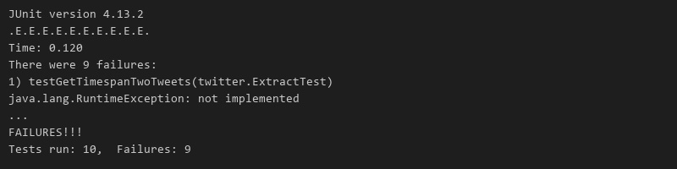

3. Code for Extract.java and ExtractTest passing
public static Timespan getTimespan(List<Tweet> tweets) {
if (tweets.isEmpty()) return new Timespan(Instant.EPOCH, Instant.EPOCH);
Instant start = tweets.get(0).getTimestamp();
Instant end = start;
for (Tweet tweet : tweets) {
Instant time = tweet.getTimestamp();
if (time.isBefore(start)) start = time;
if (time.isAfter(end)) end = time;
}
return new Timespan(start, end);
}
private static final Pattern MENTION = Pattern.compile("(?<![A-Za-z0-9_-])@([A-Za-z0-9_-]+)");
public static Set<String> getMentionedUsers(List<Tweet> tweets) {
Set<String> mentioned = new HashSet<>();
for (Tweet tweet : tweets) {
Matcher matcher = MENTION.matcher(tweet.getText());
while (matcher.find()) mentioned.add(matcher.group(1).toLowerCase(Locale.ROOT));
}
return mentioned;
}
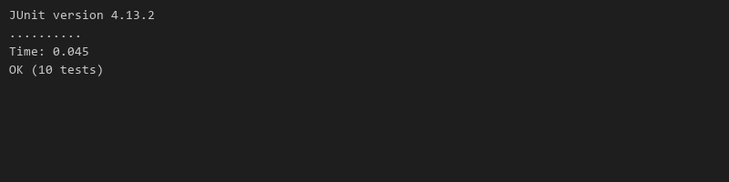

4. FilterTest failing before the implementation
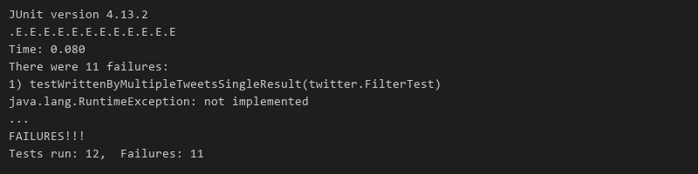

5. Code for Filter.java and FilterTest passing
public static List<Tweet> writtenBy(List<Tweet> tweets, String username) {
List<Tweet> result = new ArrayList<>();
for (Tweet tweet : tweets) {
if (tweet.getAuthor().equalsIgnoreCase(username)) result.add(tweet);
}
return result;
}
public static List<Tweet> inTimespan(List<Tweet> tweets, Timespan timespan) {
List<Tweet> result = new ArrayList<>();
for (Tweet tweet : tweets) {
if (!tweet.getTimestamp().isBefore(timespan.getStart()) && !tweet.getTimestamp().isAfter(timespan.getEnd())) {
result.add(tweet);
}
}
return result;
}
public static List<Tweet> containing(List<Tweet> tweets, List<String> words) {
List<Tweet> result = new ArrayList<>();
for (Tweet tweet : tweets) {
if (hasAnyWord(tweet.getText(), words)) result.add(tweet);
}
return result;
}
private static boolean hasAnyWord(String text, List<String> words) {
for (String tweetWord : text.split(" ")) {
for (String word : words) {
if (!tweetWord.isEmpty() && tweetWord.equalsIgnoreCase(word)) return true;
}
}
return false;
}
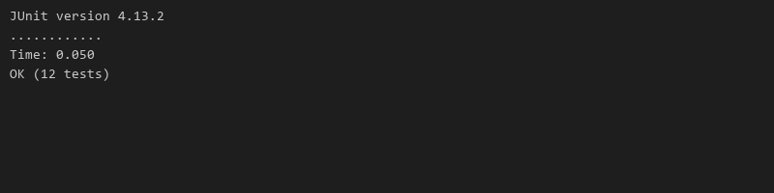

6. All tests passing and Main console output
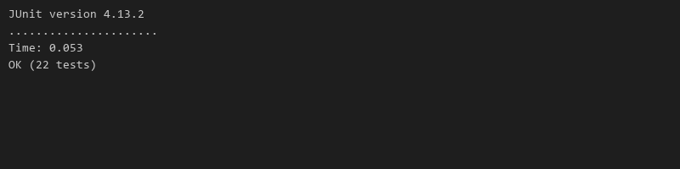
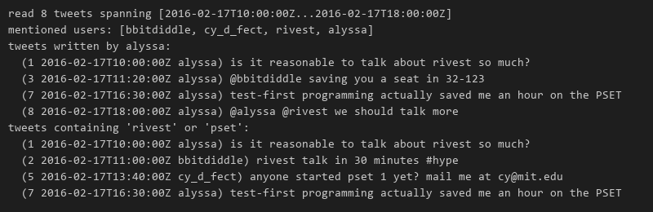

Task 1 (Problem 1): Extract

Testing strategy for ExtractTest
* Testing strategy for getTimespan(tweets):
* number of tweets: 1, > 1
* order of tweets in the list: in time order, not in time order
* timestamps: all the same, some different
* (empty list is not tested: the spec does not say what to return)
*
* Testing strategy for getMentionedUsers(tweets):
* number of tweets: 1, > 1
* mentions in a tweet: 0, 1, > 1
* same user mentioned: once, more than once with different case
* position of mention: start of text, middle, end
* "@" preceded by a username character (email address): yes, no
* mention followed by punctuation: yes, no

ExtractTest failing before implementation

Implementation of Extract.java
public static Timespan getTimespan(List<Tweet> tweets) {
if (tweets.isEmpty()) return new Timespan(Instant.EPOCH, Instant.EPOCH);
Instant start = tweets.get(0).getTimestamp();
Instant end = start;
for (Tweet tweet : tweets) {
Instant time = tweet.getTimestamp();
if (time.isBefore(start)) start = time;
if (time.isAfter(end)) end = time;
}
return new Timespan(start, end);
}
private static final Pattern MENTION = Pattern.compile("(?<![A-Za-z0-9_-])@([A-Za-z0-9_-]+)");
public static Set<String> getMentionedUsers(List<Tweet> tweets) {
Set<String> mentioned = new HashSet<>();
for (Tweet tweet : tweets) {
Matcher matcher = MENTION.matcher(tweet.getText());
while (matcher.find()) mentioned.add(matcher.group(1).toLowerCase(Locale.ROOT));
}
return mentioned;
}

ExtractTest passing after implementation

Task 2 (Problem 2): Filter

Testing strategy for FilterTest
* Testing strategy for writtenBy(tweets, username):
* number of tweets: 0, 1, > 1
* number of tweets by username: 0, 1, > 1
* case of username: same as author, different from author
*
* Testing strategy for inTimespan(tweets, timespan):
* number of tweets: 0, > 1
* tweets inside timespan: none, some, all
* tweet exactly on start or end of timespan: yes, no
*
* Testing strategy for containing(tweets, words):
* number of words: 1, > 1
* matching tweets: none, some, all
* case of word: same as in tweet, different
* word appears only as part of a bigger word: yes, no

FilterTest failing before implementation

Implementation of Filter.java
public static List<Tweet> writtenBy(List<Tweet> tweets, String username) {
List<Tweet> result = new ArrayList<>();
for (Tweet tweet : tweets) {
if (tweet.getAuthor().equalsIgnoreCase(username)) result.add(tweet);
}
return result;
}
public static List<Tweet> inTimespan(List<Tweet> tweets, Timespan timespan) {
List<Tweet> result = new ArrayList<>();
for (Tweet tweet : tweets) {
if (!tweet.getTimestamp().isBefore(timespan.getStart()) && !tweet.getTimestamp().isAfter(timespan.getEnd())) {
result.add(tweet);
}
}
return result;
}
public static List<Tweet> containing(List<Tweet> tweets, List<String> words) {
List<Tweet> result = new ArrayList<>();
for (Tweet tweet : tweets) {
if (hasAnyWord(tweet.getText(), words)) result.add(tweet);
}
return result;
}
private static boolean hasAnyWord(String text, List<String> words) {
for (String tweetWord : text.split(" ")) {
for (String word : words) {
if (!tweetWord.isEmpty() && tweetWord.equalsIgnoreCase(word)) return true;
}
}
return false;
}

FilterTest passing after implementation

Integration & Execution

All tests passing together

Main.java Console Output

